
DSA-0606 DATA HANDLING AND VISUALIZATION

EXPLORATORY DATA ANALYSIS OF SEASONAL DISEASE PATTERNS IN HOSPITAL OUTPATIENT VISITS

GROUP 2

Particular | Details
Department | Computer Science and Engineering
Programme | Computer Science and Engineering
Course | DSA-0606 – Data Handling and Visualization
Academic Year / Batch | 2026
Faculty Name | Dr. L. Karthikeyan
Date of Submission | 04-09-2026
Maximum Marks | 100

A. ASSIGNMENT INFORMATION
This assignment applies data handling and visualization techniques to an anonymized hospital outpatient dataset. The work is structured according to the Common Course Assignment Format and emphasizes problem formulation, application of course knowledge, methodology, modern tools, validation, analysis, professional responsibility, reflection, and references.
Particular | Details
Department | Computer Science and Engineering
Programme | Computer Science and Engineering
Course Code & Course Name | DSA-0606 – Data Handling and Visualization
Academic Year / Batch | 2026
Faculty Name | Dr. L. Karthikeyan
Assignment Title | Exploratory Data Analysis of Seasonal Disease Patterns in Hospital Outpatient Visits
Date of Issue | 31-08-2026
Date of Submission | 04-09-2026
Maximum Marks | 100
Course Outcome(s) – CO | CO1 – Data Cleaning; CO2 – Classification; CO3 – Bar Charts; CO4 – Heatmaps; CO5 – Time-Series Analysis
Bloom's Taxonomy Level | L3 – Apply; L4 – Analyze; L5 – Evaluate
SDG Mapping | SDG 3 – Good Health and Well-Being; SDG 9 – Industry, Innovation and Infrastructure
Industry / Societal Relevance | Hospital operations, outpatient service planning, staffing, resource allocation and healthcare data analysis
Course Concepts Applied
The project directly connects the assignment with five major concepts. Data cleaning organizes patient records by removing errors and duplicates. Classification groups patients according to age, illness, and season. Bar charts compare illnesses across different seasons and age groups. Heatmaps visualize seasonal illness patterns and patient visit frequencies. Time-series analysis identifies trends and recurring patterns and provides a foundation for future patient-demand forecasting.

B. ASSIGNMENT PROBLEM / CHALLENGE
Hospital outpatient departments generate a large volume of operational information every day. Patient visits vary according to symptoms, diagnosis categories, demographic groups, time periods, and seasonal conditions. When this information remains in raw tabular form, it can be difficult for administrators to identify recurring patterns and prepare resources before periods of increased demand.
The central challenge of this assignment is to transform anonymized outpatient records into meaningful information through a systematic exploratory data analysis process. The analysis must begin with data quality assessment and preprocessing. It must then organize illnesses and patient groups into suitable categories and use visualizations to communicate the resulting patterns.
The project is not intended to function as a clinical diagnostic system. Its purpose is operational and analytical: to help understand historical outpatient workload and provide evidence that may support staffing, service-capacity, and resource-planning decisions. Any seasonal relationship observed in the data must therefore be described as a historical association rather than proof of a medical cause.
Assignment Expectations
- Apply course concepts rather than reproduce theoretical definitions.
- Identify the structure and quality of the outpatient dataset.
- Clean missing, duplicate, inconsistent, and invalid records using documented rules.
- Classify records by illness, age group, season, and time period.
- Create suitable bar charts, heatmaps, and time-series visualizations.
- Interpret the visual outputs and identify recurring or high-demand periods.
- Validate the transformed dataset and explain limitations.
- Translate analytical findings into practical recommendations for hospital planning.

C. PROBLEM STATEMENT
A hospital's outpatient department has anonymized patient visit records containing symptoms, diagnosis codes, age groups, and visit dates over two years. The team must clean the dataset, group and categorize illnesses by season and age group, and create visualizations that help hospital administrators anticipate seasonal disease surges and plan staff and resource allocation accordingly.
Aim
The aim of the project is to analyze historical outpatient visit records and identify meaningful seasonal and age-group patterns in illnesses so that hospital administrators can make better-informed decisions about staffing and resource allocation.
Objectives
- Inspect and understand the structure and quality of the outpatient dataset.
- Identify and handle missing, duplicate, inconsistent, and invalid records.
- Standardize diagnosis codes, illness categories, age groups, and date formats.
- Categorize outpatient visits according to seasons and age groups.
- Measure the frequency and distribution of illnesses across different seasons.
- Analyze which age groups experience higher proportions of particular illness categories.
- Identify recurring periods of increased outpatient visits.
- Create clear and meaningful visualizations for administrative decision-making.
- Develop practical recommendations for seasonal staffing and resource planning.
Key Analytical Questions
- Which season has the highest number of outpatient visits?
- Which illness categories increase most during each season?
- Which age group contributes the greatest number of visits in each season?
- Are seasonal patterns similar across both years?
- Are some illness categories concentrated strongly within particular age groups?
- Do peaks recur at approximately the same time each year?
- Which periods may require additional staff or resources?

D. REQUIREMENTS AND CONSTRAINTS
The assignment requires a complete analytical workflow in which each transformation can be explained and validated. The requirements below ensure that the final analysis remains technically sound, reproducible, and responsible.
Requirement | Description
Requirement | Description
Functional | Load, clean, classify, summarize and visualize anonymized OPD records.
Data quality | Check missing values, duplicates, inconsistent labels, invalid dates and suspicious values.
Classification | Create consistent illness, age-group and seasonal categories based on the available data.
Visualization | Use appropriate charts for trends, comparisons and concentrated patterns.
Validation | Verify transformations, record counts, dates, categories and outputs.
Privacy | Use anonymized records and present results only in aggregate form.
Reliability | Document important assumptions and cleaning decisions.
Time/Resources | Use available dataset and computing environment efficiently.
Ethics | Do not identify individuals or make individual clinical decisions from the analysis.
Constraints
- The source dataset covers a limited two-year period, which may not represent long-term seasonal behavior.
- The actual categories must be derived from the available dataset rather than invented after seeing desired results.
- Records with missing dates cannot be reliably assigned to a season unless the date can be recovered.
- Duplicate records should be removed only when there is sufficient evidence that they represent the same visit.
- Season definitions should reflect the hospital's regional climate and must be applied consistently.
- Visit frequency should not be interpreted as disease severity.
- Historical patterns cannot guarantee future patient demand.
E. STUDENT WORK
1. Problem Understanding and Formulation
The dataset represents anonymized outpatient department visits collected over a two-year period. Each row represents a patient visit and the columns describe selected characteristics of that visit. The important variables include visit date, symptoms, diagnosis code, age group, and, where available, an anonymized visit identifier. The analysis converts individual records into aggregate information that can be interpreted by hospital administrators.
The first task is to understand what the dataset actually contains before changing it. The team should inspect the number of rows and columns, data types, unique values, missing-value counts, duplicate records, diagnosis labels, symptom labels, age-group labels, and date ranges. This prevents incorrect assumptions from entering later stages.
Important Variables
Variable | Description | Role in Analysis
Visit Date | Date on which the outpatient visit occurred. | Seasonal and time-based analysis
Symptoms | Reported symptoms associated with the visit. | Symptom frequency and grouping
Diagnosis Code | Recorded diagnosis code or description. | Illness categorization
Age Group | Age category of the patient. | Demographic comparison
Visit ID | Anonymized identifier, if available. | Duplicate checking and record tracking

Data Understanding Checklist
- Count the number of records and variables.
- Inspect data types for every column.
- Calculate missing-value counts and percentages.
- Check for exact duplicate rows.
- Check repeated visit identifiers where available.
- Review unique diagnosis and symptom labels.
- Check whether age groups follow one naming convention.
- Verify that visit dates fall within the expected period.
- Identify impossible or suspicious values for investigation.
2. Application of Course Knowledge
2.1 Data Cleaning
Data cleaning is the foundation of the project because unreliable input data can produce misleading patterns. Missing values should first be measured instead of automatically deleted. If a visit date is missing and cannot be recovered, that record should be excluded from seasonal analysis because assigning a season without a date would be inappropriate. Missing symptoms may be represented as 'Not recorded' when the visit remains useful for other analyses.
Duplicate visits can artificially increase disease counts. Exact duplicate rows should be identified and removed. If a visit identifier is available, repeated identifiers should be investigated carefully because repeated visits by the same patient are not necessarily duplicates. A record should be removed only when evidence indicates that it represents the same visit.
2.2 Classification
Classification organizes raw records into categories that can be compared. Diagnosis codes or descriptions may be mapped into broader illness categories such as respiratory illnesses, gastrointestinal illnesses, vector-borne illnesses, skin-related illnesses, and other categories that are actually supported by the dataset. Age groups should also be represented using consistent labels. The classification rules must be applied consistently across the complete two-year period.
2.3 Bar Charts
Bar charts provide a straightforward method for comparing categorical quantities. In this project, they can compare total visits by season, illness frequency, age-group distributions, and age-group workload within each season. Proper titles, axis labels, legends, and category names are important because the visualization must be understandable without requiring the viewer to inspect the raw data.
2.4 Heatmaps
Heatmaps are useful when several categorical dimensions need to be compared simultaneously. A season–illness heatmap can place seasons on one axis and illness categories on the other, with cell intensity representing visit counts or percentages. This makes concentrated combinations visible quickly and supports administrative interpretation of high-demand season–illness relationships.
2.5 Time-Series Analysis
Time-series analysis considers outpatient visits in chronological order. Monthly visit counts can be plotted across the complete two-year period. The resulting line chart can reveal increases, decreases, fluctuations, and recurring peaks. Comparing the same months across both years can help distinguish a repeated seasonal pattern from an isolated increase.
3. SOLUTION / DESIGN / METHODOLOGY
The proposed solution follows a sequential workflow: data acquisition, inspection, cleaning, classification, feature creation, exploratory summaries, visualization, validation, interpretation, and recommendation. The workflow is designed so that each stage produces information needed by the next stage.
3.1 Overall Workflow
- Load the anonymized outpatient dataset.
- Inspect structure, dimensions, data types and missing values.
- Remove confirmed duplicate records.
- Standardize diagnosis and symptom labels.
- Standardize age-group categories.
- Convert visit dates to a consistent date format.
- Create year, month, month number and season variables.
- Map diagnosis codes into meaningful illness categories.
- Generate grouped summaries by season and age group.
- Create line charts, bar charts, stacked charts, grouped charts and heatmaps.
- Validate the cleaned and transformed data.
- Interpret results and identify recurring high-demand periods.
- Prepare recommendations for staffing and resource allocation.
3.2 Seasonal Categorization
Each visit date can be mapped to a season using a predefined calendar or climate-based rule. A three-season framework such as summer, monsoon, and winter may be suitable where it reflects the regional climate. A four-season framework may be used if it is supported by the dataset and local context. The important requirement is consistency: the same rule must be applied to both years so that seasonal comparisons remain valid.
3.3 Age-Group Categorization
Age groups allow the project to examine whether selected illness categories are concentrated among particular populations. The analysis should use the categories supplied by the dataset where practical. If transformation is necessary, the mapping rule should be documented and applied uniformly.
3.4 Cross-Tabulation
Cross-tabulation combines season, age group, and illness category. For example, respiratory-related visits can be compared across children, adults, and older adults during each season. This provides more detailed information than analyzing each dimension separately and can reveal combinations that may be important for workload planning.
3.5 Analytical Measures
- Total outpatient visits.
- Monthly visit counts.
- Season-wise visit counts.
- Illness-category frequency and percentage.
- Age-group frequency and percentage.
- Season-wise illness distribution.
- Age-group-wise illness distribution.
- Monthly and seasonal peak values.
- Two-year comparison of recurring periods.
4. USE OF MODERN TOOLS
Python is the proposed implementation environment because it provides suitable libraries for data manipulation, numerical operations, statistical analysis, and visualization. Pandas can be used for data cleaning and grouping, NumPy for numerical processing, Matplotlib and Seaborn for visualization, and Jupyter Notebook or another Python environment for documenting the analysis.
Tool | Purpose
Tool | Purpose
Python | Main programming and analysis environment
Pandas | Data loading, cleaning, transformation and grouped summaries
NumPy | Numerical operations and supporting calculations
Matplotlib | Line charts, bar charts and other visualizations
Seaborn | Heatmaps and enhanced statistical visualizations
Jupyter Notebook | Interactive implementation, documentation and evidence
Modern tools should not be used merely for producing attractive graphics. The team should provide evidence that the tools were used to inspect, transform, analyze, visualize, and validate the data. Screenshots of important outputs and implementation steps can be included in the final submission.
5. RESULTS AND VALIDATION
The source material specifies expected outputs but does not provide the actual numerical results of the dataset. Therefore, numerical findings should be inserted only after the analysis is executed. The final report should contain the generated tables, charts, heatmaps, and time-series outputs, together with short interpretations for each.
5.1 Recommended Visualization Plan
Visualization | Purpose | Administrative Use
Visualization | Purpose | Administrative Use
Line chart | Show monthly visit trends | Identify timing of demand peaks
Bar chart | Compare seasonal totals | Plan staffing by season
Stacked bar chart | Show illness composition | Prepare relevant resources
Grouped bar chart | Compare age groups | Anticipate demographic workload
Heatmap | Show concentrated patterns | Identify high-demand combinations quickly
Age-group illness chart | Compare illnesses across demographic groups | Support workload planning
5.2 Validation Procedure
- Record the number of rows and columns before preprocessing.
- Record the number of duplicate records identified and removed.
- Compare record counts before and after cleaning.
- Verify that dates are valid and within the expected two-year period.
- Verify that every record included in seasonal analysis has a valid season.
- Check for unexpected age-group labels after standardization.
- Check for unexpected illness categories after classification.
- Verify that grouped totals reconcile with the cleaned dataset.
- Check that charts represent the corresponding summary tables correctly.
5.3 Expected Output Interpretation
The analysis is expected to identify seasons with relatively high outpatient attendance, illness categories that contribute strongly to seasonal increases, age groups with higher visit frequencies for selected illness categories, recurring peaks across the two-year period, and unusual increases requiring further investigation. These are expected analytical outputs rather than predetermined findings.
6. ANALYSIS AND ENGINEERING DECISION
The analytical stage converts visual and statistical observations into practical decisions. If historical data indicates that outpatient demand increases during a particular period, administrators can consider additional staffing during that period. The decision should not depend only on total visits; the illness categories responsible for the increase and the age groups contributing to the workload should also be examined.
6.1 Interpretation of Seasonal Surges
A seasonal surge should be treated as a historical pattern in the dataset. If an illness category repeatedly records higher visit counts during one season in both years, the hospital may consider preparing for increased demand during that period. However, external factors such as outbreaks, environmental conditions, reporting practices, population changes, and operational events can influence the observed counts.

6.2 Comparison of Alternatives
Approach | Strength | Limitation
Approach | Strength | Limitation
Raw frequency tables | Simple and transparent | Difficult to interpret quickly with many categories
Bar charts | Easy categorical comparison | Less suitable for detailed multi-dimensional patterns
Heatmaps | Compact multi-category comparison | Requires careful legend and scale interpretation
Time-series line chart | Shows chronological trends and recurring peaks | Does not by itself explain causes
Combined EDA approach | Provides complementary views of demand | Requires consistent preprocessing across outputs
The combined EDA approach is selected because no single visualization answers all project questions. Line charts are best for temporal order, bar charts for categorical comparisons, and heatmaps for concentrated relationships between categories. Together they provide a more complete administrative picture.
6.3 Decision Support
- Schedule additional staff during historically high-demand periods where appropriate.
- Prepare registration and consultation capacity for predictable workload increases.
- Consider waiting-area and appointment-slot requirements.
- Prepare relevant support resources according to illness-category patterns.
- Use historical peaks as reference points for monitoring current activity.
- Investigate unusual increases rather than automatically interpreting them as disease outbreaks.

7. BROADER CONSIDERATIONS
7.1 Sustainability
Using historical demand information can improve the efficiency of staffing and resource allocation. Instead of distributing resources uniformly across all periods, administrators can use evidence about historical workload to consider where additional capacity may be needed. Better planning can reduce unnecessary resource underutilization while maintaining preparedness during higher-demand periods.
7.2 Society
Efficient outpatient planning can contribute to improved service readiness. When hospitals anticipate periods of increased workload, they can consider appropriate staffing and service capacity in advance. This may help reduce operational pressure and improve the ability of outpatient departments to manage patient flow.
7.3 Safety
The analysis is an operational decision-support exercise and must not be used as a substitute for clinical diagnosis or emergency medical judgment. Historical visit counts indicate workload patterns, not the severity of individual cases.
7.4 Ethics and Privacy
The dataset is anonymized and the project should preserve this property throughout implementation. Personally identifying information should not be introduced, displayed, or inferred. Results should be presented in aggregate form. The analysis should not attempt to identify individual patients or make clinical decisions about specific people.
7.5 Professional Responsibility
A responsible analysis documents cleaning rules, assumptions, limitations, and interpretation. The team should avoid selecting a visualization merely because it produces a preferred result. All findings should be derived from the actual dataset and supported by corresponding tables or charts.
8. CONCLUSION
This project demonstrates how exploratory data analysis can be applied to anonymized hospital outpatient records to support practical administrative decision-making. By cleaning patient visit data, standardizing diagnosis and age-group categories, and converting visit dates into meaningful seasonal groups, raw records can be transformed into structured information.
The analysis focuses on identifying when outpatient demand increases, which illness categories contribute to those increases, and which age groups are most represented during different periods. Line charts, bar charts, stacked charts, grouped charts, and heatmaps provide complementary ways to communicate these patterns.
The most important outcome is not simply a collection of graphs but a structured approach for turning historical outpatient data into planning information. If recurring seasonal patterns are identified, administrators can use them to consider staffing, service capacity, and resource allocation before expected high-demand periods.
The project also demonstrates the importance of responsible healthcare data handling. Since patient information is sensitive, anonymization, aggregation, privacy protection, and careful interpretation are essential. The final findings should remain operational insights rather than individual clinical recommendations.
9. STUDENT REFLECTION
This assignment provides practical learning beyond classroom theory because it requires the complete transformation of raw records into interpretable information. The team learns that data analysis is not limited to creating graphs; the reliability of every result depends on the quality of the original records and the decisions made during preprocessing.
The project strengthens understanding of data cleaning by showing how missing values, duplicate records, inconsistent labels, and invalid dates can affect analysis. It also develops classification skills because the same raw records must be organized into consistent illness, age, and seasonal categories before comparisons can be made.
The visualization stage provides experience in selecting the correct graphical representation for a particular analytical question. Bar charts are useful for categorical comparisons, heatmaps are useful for multi-category concentration patterns, and line charts are useful for chronological trends. This demonstrates that visualization is part of analytical reasoning rather than only presentation.
If additional time and resources were available, the project could be extended using a larger dataset covering more years, an interactive dashboard, real-time monitoring, forecasting models, automated alerts, and resource-utilization information. These improvements could make the system more proactive while retaining the exploratory foundation developed in the current assignment.

10. REFERENCES
- Wickham, H., & Grolemund, G. (2017). R for Data Science: Tidy, Transform, Visualize, and Understand Data. O'Reilly Media.
- McKinney, W. (2022). Python for Data Analysis: Data Wrangling with pandas, NumPy, and Jupyter. O'Reilly Media.
- VanderPlas, J. (2016). Python Data Science Handbook: Essential Tools for Data Science. O'Reilly Media.
- McKinney, W. (2010). Data Structures for Statistical Computing in Python. Proceedings of the 9th Python in Science Conference.
- Hunter, J. D. (2007). Matplotlib: A 2D Graphics Environment. Computing in Science & Engineering, 9(3), 90–95.
- Pedregosa, F., et al. (2011). Scikit-learn: Machine Learning in Python. Journal of Machine Learning Research, 12, 2825–2830.
- World Health Organization. Health data and digital health resources for strengthening health information systems.
- Pandas Documentation. Data analysis and manipulation using Python.
- Matplotlib Documentation. Visualization with Python.
F. COMMON ASSESSMENT RUBRIC
Assessment Criterion | Marks
Problem understanding & formulation | 10
Application of course/domain knowledge | 20
Solution methodology / design / implementation | 20
Use of appropriate modern tools / techniques | 10
Results, testing & validation | 15
Analysis, trade-offs & justification | 15
Broader considerations / professional responsibility | 5
Technical documentation & reflection | 5
TOTAL | 100
G. CO–PO–ASSESSMENT MAPPING
Assessment Component | CO | PO(s) | Bloom's Level / Marks
Problem formulation | CO1 | Relevant PO(s) | L3/L4 – 10
Application of knowledge | CO1–CO2 | Relevant PO(s) | L3/L4 – 20
Solution / Design / Implementation | CO2–CO5 | Relevant PO(s) | L4/L5/L6 – 20
Modern tool usage | CO1–CO5 | Relevant PO(s) | L3/L4 – 10
Validation | CO3–CO5 | Relevant PO(s) | L4/L5 – 15
Analysis & justification | CO2–CO5 | Relevant PO(s) | L4/L5 – 15
Broader considerations | Relevant CO | Relevant PO(s) | L4/L5 – 5
Documentation & reflection | Relevant CO | Relevant PO(s) | L3/L4 – 5

H. FACULTY EVALUATION & CONTINUOUS IMPROVEMENT
- Target CO Attainment: __________________________
- Actual CO Attainment: __________________________
- Areas in which students performed well: ____________________________________________
- Areas requiring improvement: ______________________________________________________
- Corrective / Improvement Action: __________________________________________________
- Action to be implemented in the next offering: ______________________________________

Sample Code:
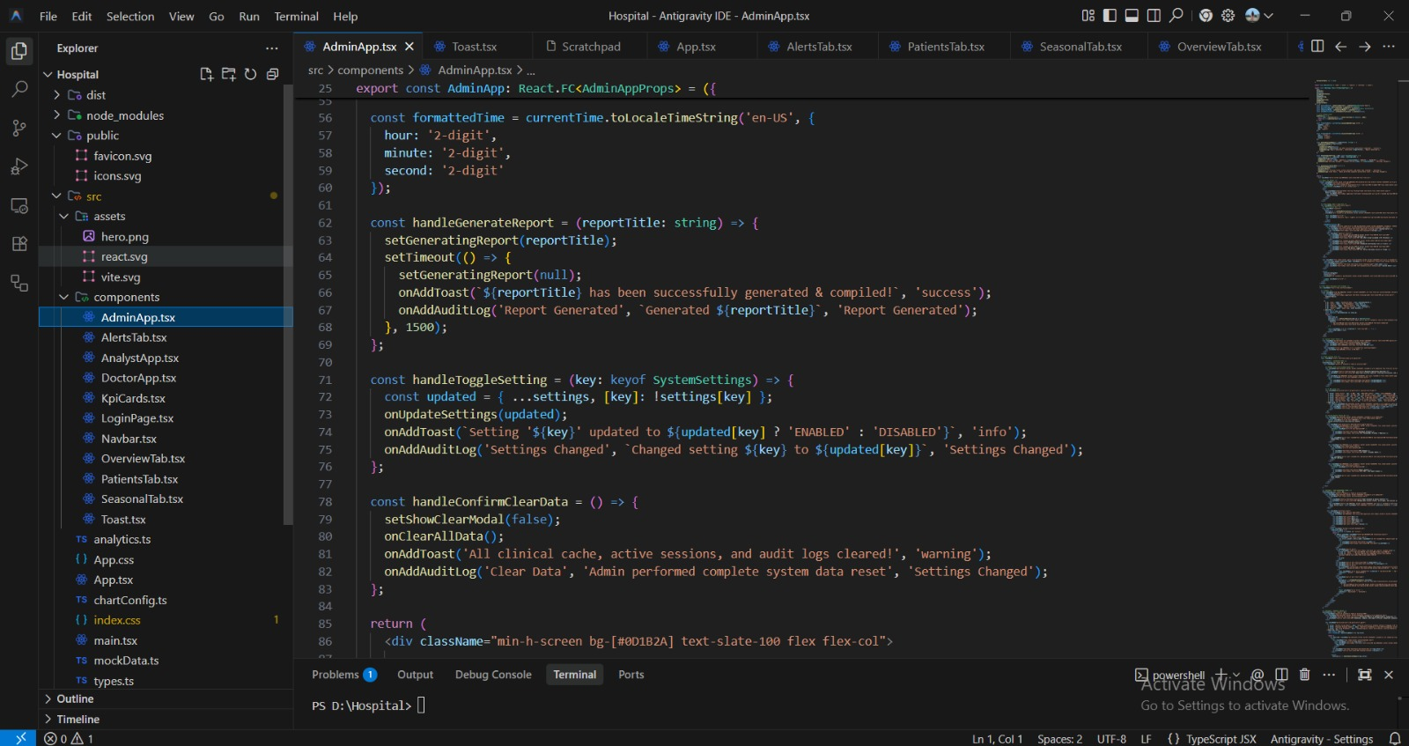
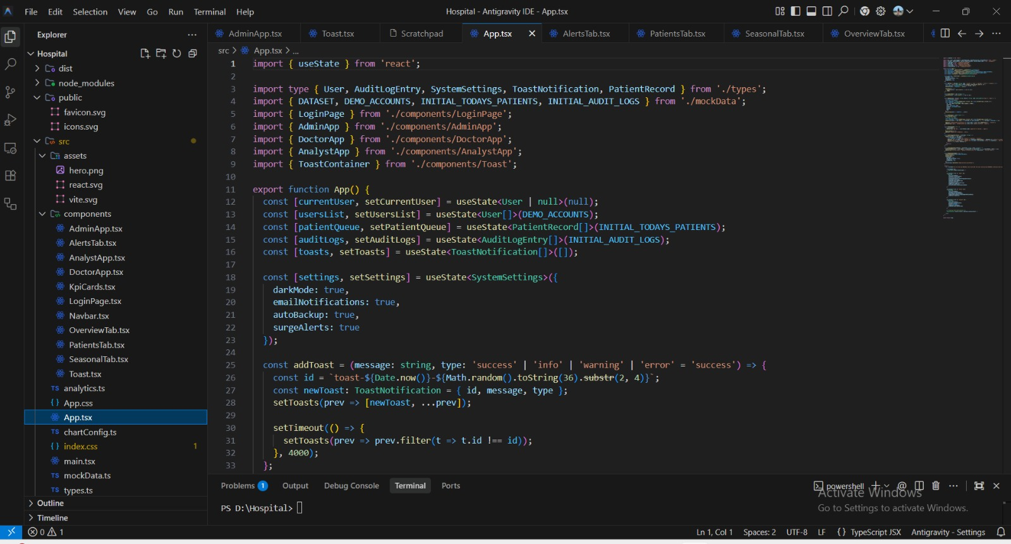

IMPLEMENTATION EVIDENCE
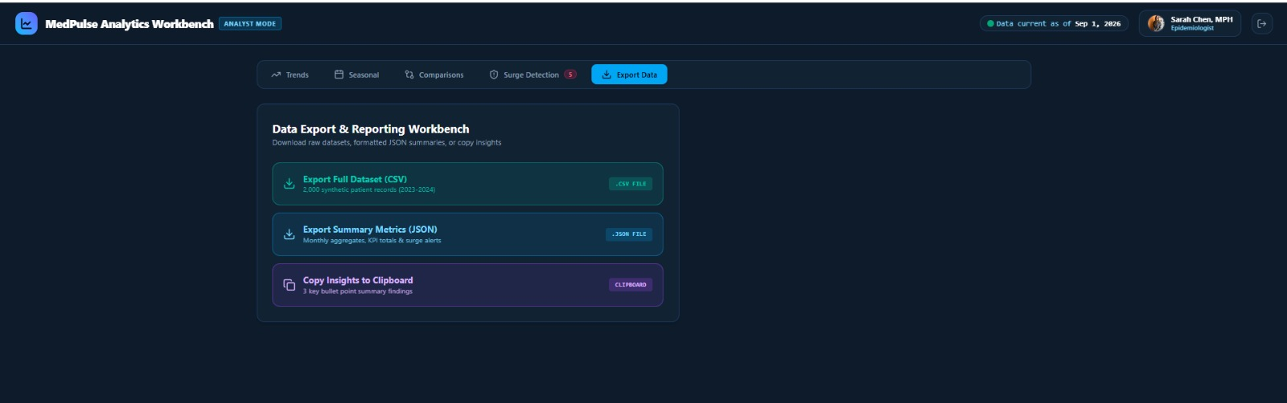
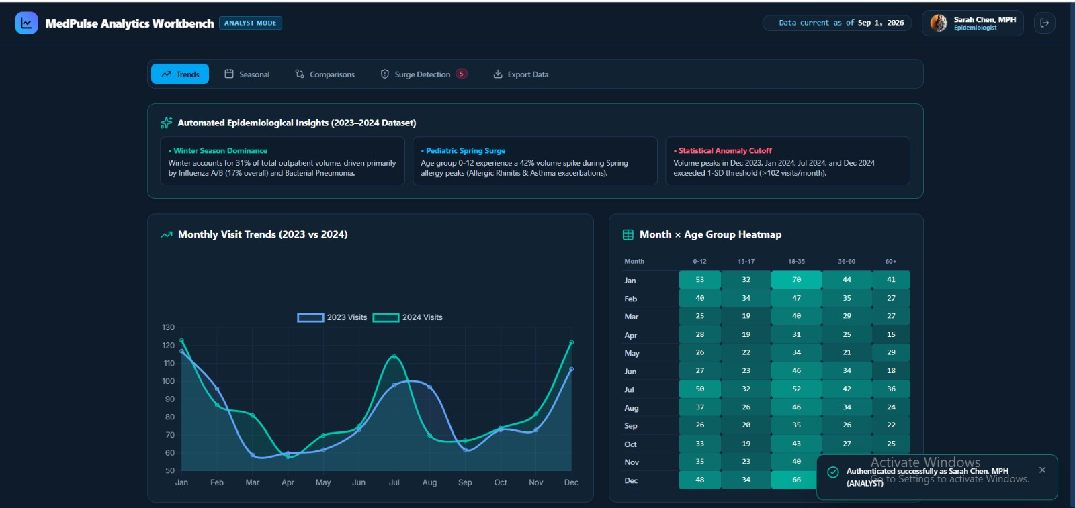
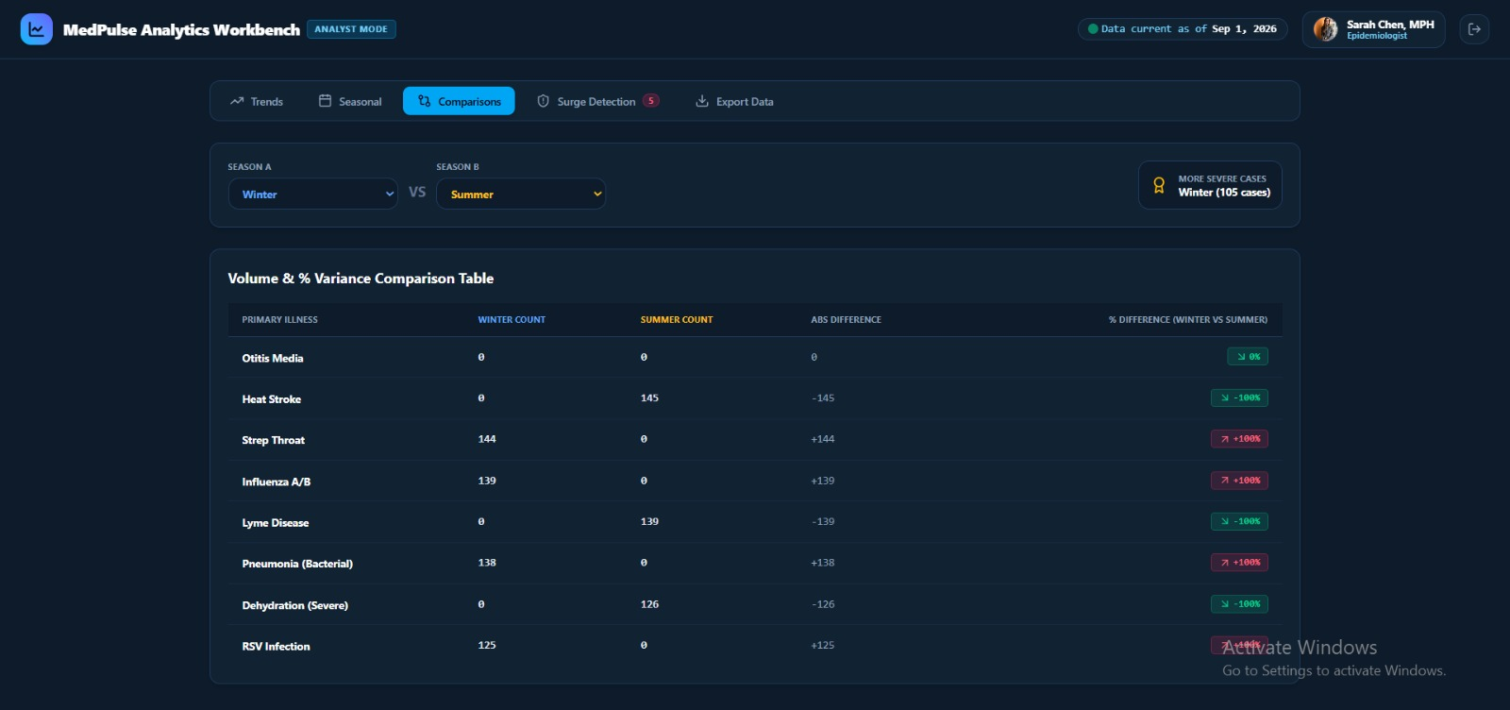
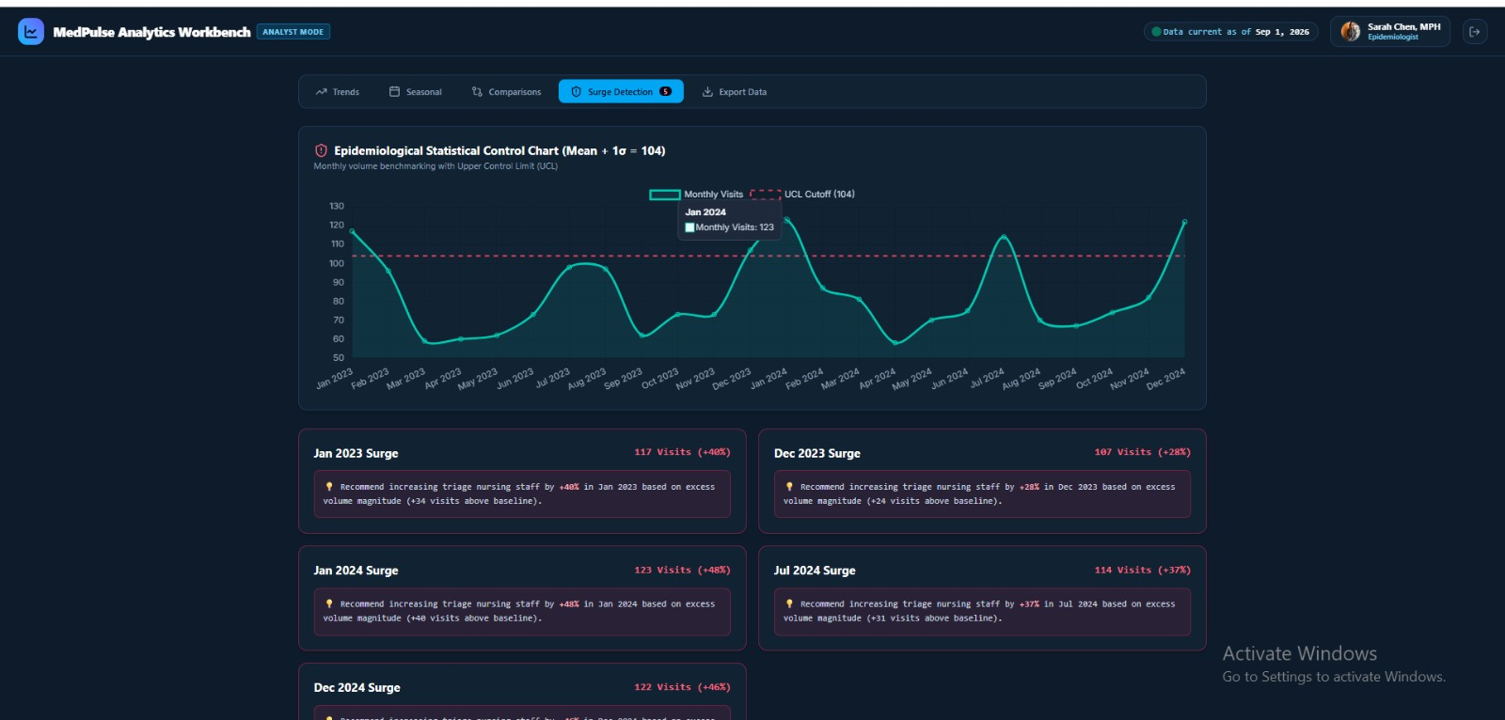
INDIVIDUAL CONTRIBUTION OF TEAM MEMBERS
Data Cleaning and Preprocessing
Member 1 was responsible for the complete data cleaning and preprocessing stage of the Seasonal Illness Analysis and Visualization for Hospital Resource Optimization project. The main responsibility was to prepare the anonymized outpatient department (OPD) patient records so that the dataset could be used effectively for further analysis. The raw dataset contained important information such as patient visit dates, symptoms, diagnosis codes, and age groups. The member first examined the structure and contents of the dataset to understand the available variables and identify potential data-quality issues.
The data was carefully checked for missing values, duplicate records, inconsistent entries, and inappropriate data formats. Duplicate records were identified and removed to avoid repeated counting of the same patient visit during the analysis. Missing values were examined and handled using suitable methods depending on the importance and nature of the particular field. The member also checked the consistency of diagnosis information because similar illnesses could sometimes be represented using different descriptions or codes. Standardizing these values helped ensure that the same illness was not treated as multiple unrelated categories during the analysis.
Another important responsibility was preparing the date information. Patient visit dates were converted into a consistent format so that monthly and seasonal analysis could be performed correctly. The member verified that the dates were valid and arranged the records chronologically where required. Age-related information was also checked to ensure that it could be used later for appropriate age-group classification.
The cleaned data was then organized into a structured dataset containing the relevant attributes required for the project. Unnecessary information that was not required for analysis was excluded from the working dataset. The member also performed basic validation after cleaning to ensure that the number of records, categories, and values were reasonable and that the preprocessing process had not introduced unnecessary errors.
Data cleaning was an important contribution because all subsequent stages of the project depend on the quality of the prepared dataset. Incorrect, duplicate, or inconsistent records could produce misleading illness frequencies and affect seasonal comparisons. By preparing a consistent and organized dataset, Member 1 provided the foundation required for patient classification, visualization, and time-based analysis.
The final responsibility involved making the processed dataset available for the next stages of the project. The cleaned dataset was reviewed to ensure that it contained the necessary information for analyzing seasonal illness patterns and patient demand. Through this work, Member 1 contributed significantly to improving the reliability, consistency, and usability of the patient data used throughout the project.
INDIVIDUAL CONTRIBUTION – MEMBER 2
Patient and Illness Classification
Member 2 was responsible for the patient, illness, and seasonal classification stage of the Seasonal Illness Analysis and Visualization for Hospital Resource Optimization project. After the raw OPD records were cleaned and organized, the member worked on transforming the available patient information into meaningful categories that could be used for comparative analysis. The primary focus was to classify patients according to age groups, organize illnesses into suitable categories, and associate patient visits with seasonal periods.
The first major task was age-group classification. The available age information was examined and patients were assigned to predefined categories such as children, adolescents, adults, and elderly patients. The classification rules were applied consistently to all applicable records so that patients belonging to similar age ranges were placed in the same category. This made it possible to compare illness frequencies between different age groups rather than analyzing individual ages separately.
The second responsibility involved organizing diagnosis codes and illness descriptions into meaningful illness categories. The member examined the diagnosis information and identified appropriate groupings for the analysis. Similar or related diagnosis descriptions were organized carefully so that the resulting categories could provide a clearer representation of illness occurrence. This step was necessary because analyzing every diagnosis code separately could make the visualization complex and difficult to interpret.
The member also performed seasonal classification using the patient visit dates. Each visit was associated with the appropriate seasonal period according to the predefined seasonal categories used in the project. This allowed the dataset to be analyzed according to relationships between illness and season. Monthly and seasonal information could then be compared with patient age groups to identify differences in illness occurrence.
An important part of this contribution was maintaining consistency throughout the classification process. The same age and seasonal rules were applied across the dataset to ensure that comparisons remained meaningful. The member also checked the resulting categories to identify incorrect assignments and corrected them where necessary.
The classified dataset was then prepared for visualization and further analysis. By combining age category, illness category, and seasonal information, the project could examine patterns such as which illnesses occurred more frequently during particular seasons and which age groups recorded higher patient visit frequencies.
This classification stage provided an important link between data preprocessing and visualization. Without appropriate classification, it would be difficult to compare the patient records effectively or generate meaningful graphical representations. Member 2 therefore contributed to transforming the cleaned OPD records into structured categories that could be used to understand seasonal illness patterns and age-wise patient distributions.
The final classified dataset supported the development of bar charts, heatmaps, and time-based analysis in the later stages of the project. This work helped make the patient information more understandable and suitable for identifying patterns that could support hospital planning and resource allocation.
INDIVIDUAL CONTRIBUTION – MEMBER 3
Bar Chart Visualization
Member 3 was responsible for the development and interpretation of bar-chart visualizations used in the Seasonal Illness Analysis and Visualization for Hospital Resource Optimization project. The main responsibility was to convert the classified OPD patient data into clear graphical representations that could be easily understood by hospital administrators and other users.
The member began by examining the processed dataset and identifying the variables that were suitable for comparison through bar charts. Important variables included illness categories, patient age groups, seasonal periods, and patient visit frequencies. The member determined which combinations of variables would provide useful information about the distribution of illnesses and patient demand.
Bar charts were developed to compare the frequency of different illnesses across the available patient records. These charts provided a straightforward way to determine which illness categories recorded higher or lower numbers of patient visits. Additional comparisons were made between different age groups to understand the distribution of illnesses among children, adolescents, adults, and elderly patients.
Grouped bar charts were also considered for comparisons involving more than one category. For example, illness frequencies could be compared across multiple seasons, allowing differences between summer, monsoon, and winter periods to be observed. Similarly, age groups could be compared for particular illness categories to identify variations in patient distribution.
The member was responsible for ensuring that the visualizations were presented clearly. Appropriate chart titles, axis labels, category names, legends, and numerical scales were included so that the information could be understood without referring directly to the raw dataset. The member also checked the graphs to avoid unnecessary visual complexity and ensured that the selected chart types were appropriate for the data being represented.
After generating the charts, Member 3 analyzed the visual patterns shown in the graphs. Higher and lower illness frequencies were identified, and comparisons were made between seasons and age groups. These observations helped connect the numerical analysis with the project's objective of understanding seasonal healthcare demand.
The member also verified the accuracy of the charts by comparing the graphical values with the summarized patient data. This validation ensured that the visualizations represented the processed dataset correctly and that no categories were incorrectly displayed or omitted.
The bar-chart visualizations provided an important communication component of the project. Instead of requiring administrators to examine large tables of patient records, the charts allowed important differences to be recognized quickly. This made the results more accessible and supported the interpretation of illness patterns.
Through this contribution, Member 3 helped transform the project's classified data into meaningful and understandable visual information. The bar charts provided a clear comparison of illnesses, age groups, and seasons and supported the broader objective of using historical OPD data to assist hospital resource planning.

INDIVIDUAL CONTRIBUTION – MEMBER 4
Heatmap Visualization
Member 4 was responsible for developing and interpreting heatmap visualizations for the Seasonal Illness Analysis and Visualization for Hospital Resource Optimization project. The main objective of this contribution was to represent relationships between illness categories, seasonal periods, and patient visit frequencies in a visual format that could be interpreted quickly.
The member first prepared the summarized data required for the heatmap. The classified patient records were organized according to illness and season, and the corresponding number of patient visits was calculated. This information was arranged into a suitable matrix structure, with illness categories and seasonal periods represented as the main dimensions of the visualization.
The heatmap was then developed to represent variations in patient visit frequency through different levels of visual intensity. Areas representing higher patient frequencies were visually distinguishable from areas representing lower frequencies. This allowed users to identify important patterns without having to examine every individual numerical value.
The member carefully selected appropriate labels for the rows and columns of the heatmap so that each illness and seasonal category could be identified clearly. A suitable legend or scale was also included to explain the relationship between visual intensity and patient frequency. The member ensured that the visualization remained readable and that the categories were arranged in a logical manner.
One of the important advantages of the heatmap was its ability to display multiple relationships at the same time. Instead of creating separate graphs for every illness and season, the heatmap provided a combined representation. This made it easier to identify seasonal periods in which particular illnesses recorded relatively higher frequencies.
Member 4 also analyzed the generated heatmaps to identify recurring patterns within the OPD records. Comparisons were made between different seasons and illness categories to determine where patient activity appeared higher or lower. The member examined the visual results alongside the underlying numerical data to ensure that the patterns observed from the heatmap were supported by the actual patient counts.
The visualization was also reviewed for clarity and accuracy. Labels, category names, and visual scales were checked to reduce the possibility of misinterpretation. The member ensured that the heatmap communicated the intended information effectively and could be understood by users who were not directly involved in the technical development.
The heatmap contribution was particularly useful for identifying relationships between seasonal periods and illness occurrence. Such visual information can help hospital administrators recognize periods that may require closer monitoring or additional preparation. It can also support comparison between multiple illness categories within the same seasonal period.
Through this work, Member 4 contributed an effective multidimensional visualization component to the project. The heatmap helped convert summarized patient data into an easily interpretable visual pattern and supported the project's objective of understanding seasonal illness trends for improved healthcare planning.
INDIVIDUAL CONTRIBUTION – MEMBER 5
Time-Series Analysis
Member 5 was responsible for performing time-series analysis of the anonymized OPD patient records collected over the two-year period. The main focus of this contribution was to analyze how patient visit frequencies changed over time and identify monthly, seasonal, and recurring patterns that could support hospital resource planning.
The member began by organizing the patient visit records according to their visit dates. The dates were arranged chronologically and patient visits were aggregated into appropriate time periods, particularly monthly intervals. This created a time-based representation of OPD activity and made it possible to observe changes in patient demand throughout the two-year observation period.
Line charts were developed to represent monthly patient visit trends. These visualizations showed increases and decreases in the number of patients visiting the OPD over time. The member examined the graphs carefully to identify periods of higher and lower patient activity, as well as fluctuations that occurred during particular months.
Seasonal patterns were also examined by comparing patient visits across different seasonal periods. The member analyzed whether similar patterns appeared during corresponding seasons across the two years. This comparison helped determine whether certain periods repeatedly showed relatively higher patient demand.
The member also considered illness-related trends within the time-series analysis. Patient visits associated with different illness categories could be examined across months or seasons to determine whether particular illnesses showed recurring increases during specific periods. These observations helped connect time-based patient demand with the seasonal illness analysis performed in the project.
An important part of the contribution was interpreting the trends rather than simply producing graphs. The member examined periods of increased OPD workload and considered their relevance to hospital operations. Higher patient volumes may require additional attention to staffing, medicines, consultation facilities, and other resources. The analysis therefore provided useful information for understanding when healthcare demand may be comparatively high.
The member also considered the role of historical trends in future demand estimation. Recurring patterns identified from the two-year dataset can provide a foundation for future forecasting approaches. However, the analysis was treated as historical trend analysis rather than a definite prediction of future disease outbreaks, since future patient demand can be influenced by many factors beyond the available dataset.
The accuracy of the time-series visualizations was checked by comparing chart values with the underlying monthly patient counts. The member ensured that the time periods were displayed in the correct chronological order and that seasonal comparisons were based on correctly classified records.
Through this contribution, Member 5 transformed date-based OPD records into meaningful information about patient demand over time. The time-series analysis helped identify trends, fluctuations, and recurring seasonal patterns and provided useful analytical information that can support hospital administrators in planning staff, medicines, facilities, and other healthcare resources.

GEOTAG PHOTO:


DOCUMENTATION CHECKLIST
- Assignment problem statement
- CO–PO and Bloom's mapping
- Assessment rubric
- Dataset description
- Data-cleaning evidence
- Classification evidence
- Visualization outputs
- Time-series analysis outputs
- Validation results
- Analysis and recommendations
- Student reflection
- References and acknowledgement of tools/data sources

